Blaise A. Johnosn

Assignment 7.2

CSD325-T301

July 13, 2025

Write a function that accepts two parameters: a city name and a country name. The function should return a single string of the form City, Country, such as **Santiago, Chile**. Store the function in a file named city_functions.py. In the same file, call the function at least three times using a City, Country values. Execute city_functions.py and take a screenshot of the results. Paste that screenshot into your Word document.

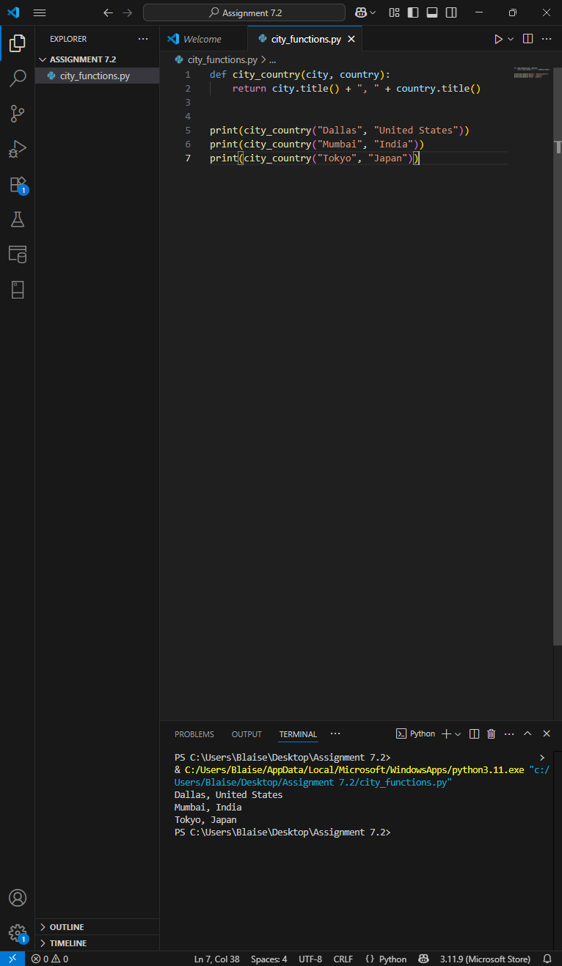

Create a file called test_cities.py that tests the function you just wrote (remember that you need to import unittest and the function you want to test). Write a method called test_city_country() to verify that calling your function with values such as santiago and chile results in the correct string. Run test_cities.py, and make sure test_city_country() passes. When it passes, take a screenshot of the result and paste in into your Word document.

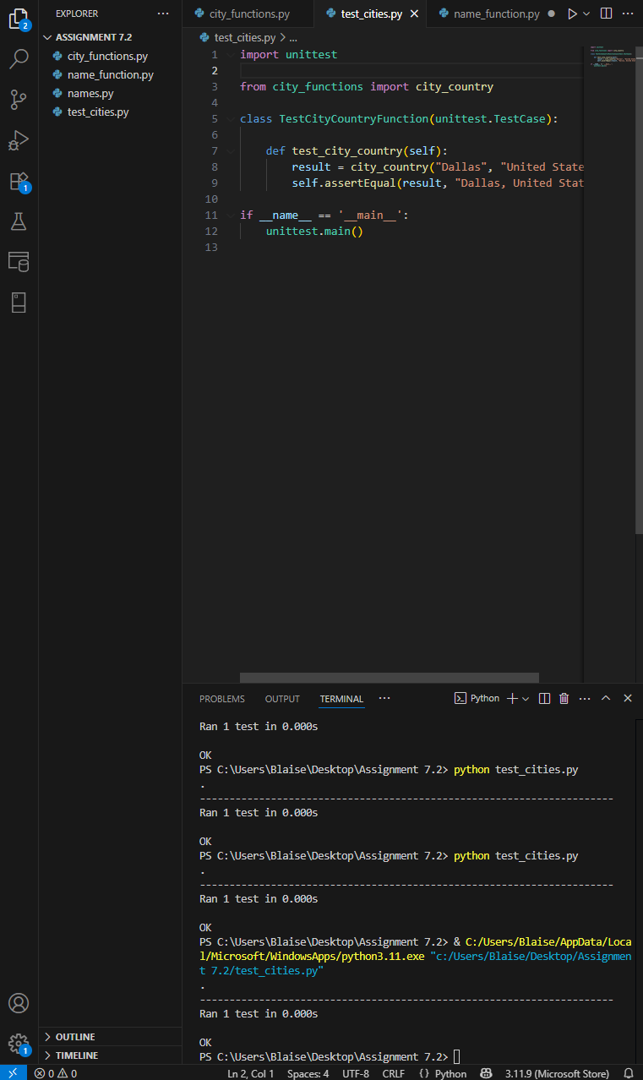

Modify your city_country function in city_functions.py so it requires a third parameter, population. It should now return a single string of the form City, Country - population xxx, such as **Santiago, Chile - population 5000000.**

Run test_cities.py again. It should fail. Take a screenshot of the result and paste into your Word document.

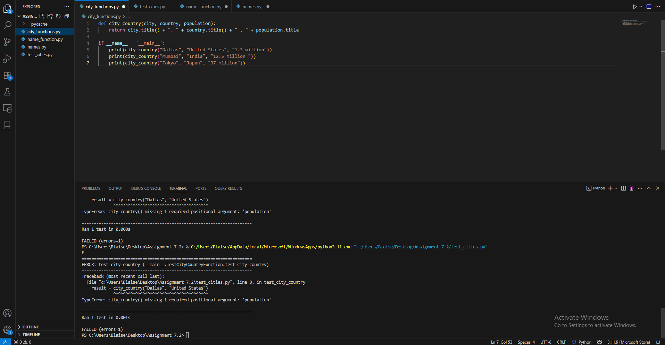

Now modify your city_country function in city_functions.py so that the population parameter is optional.

Run test_cities.py again. It should pass. Take a screenshot of the result and paste into your Word document.

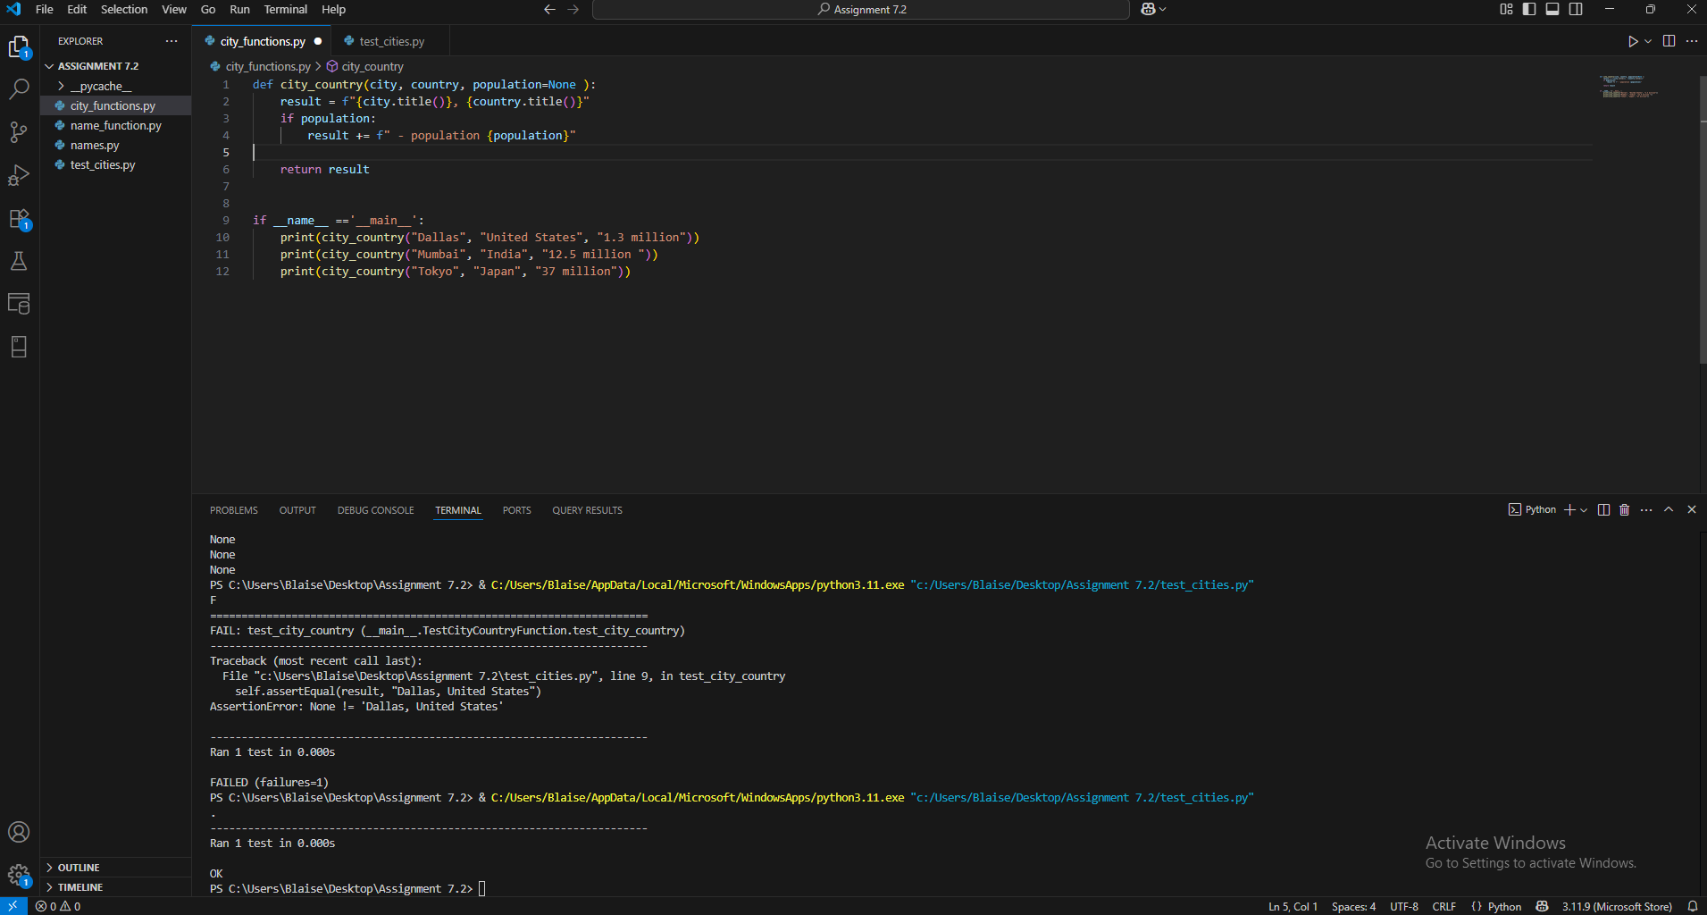

Modify your city_country function in city_functions.py so it requires a fourth parameter, language. It should now return a single string of the form City, Country - population xxx, Language, such as **Santiago, Chile - population 5000000, Spanish**.

Run test_cities.py again. It should fail. Take a screenshot of the result and paste into your Word document.

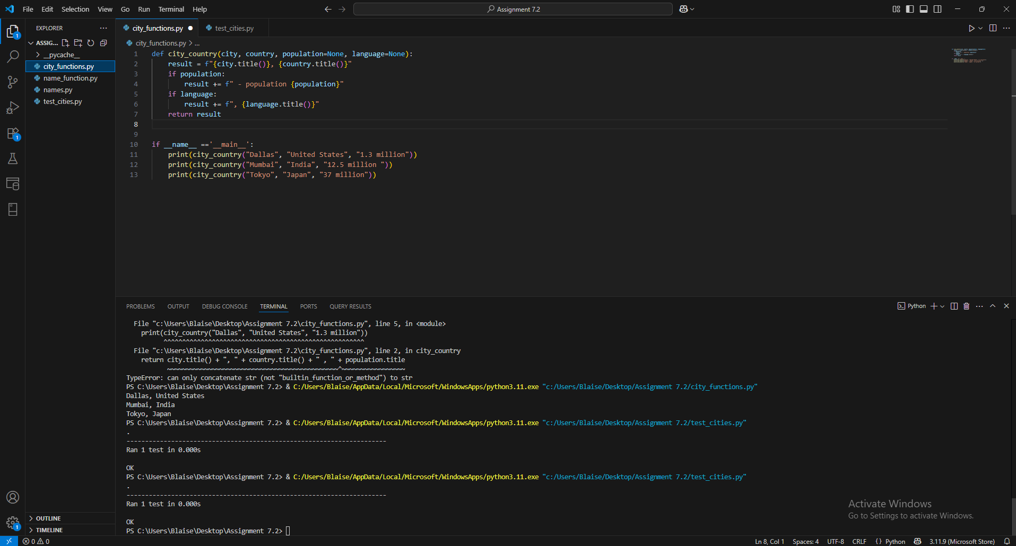

Now modify your city_country function in city_functions.py so that the language argument is optional.

Run test_cities.py again. It should pass. Take a screenshot of the result and paste into your Word document.

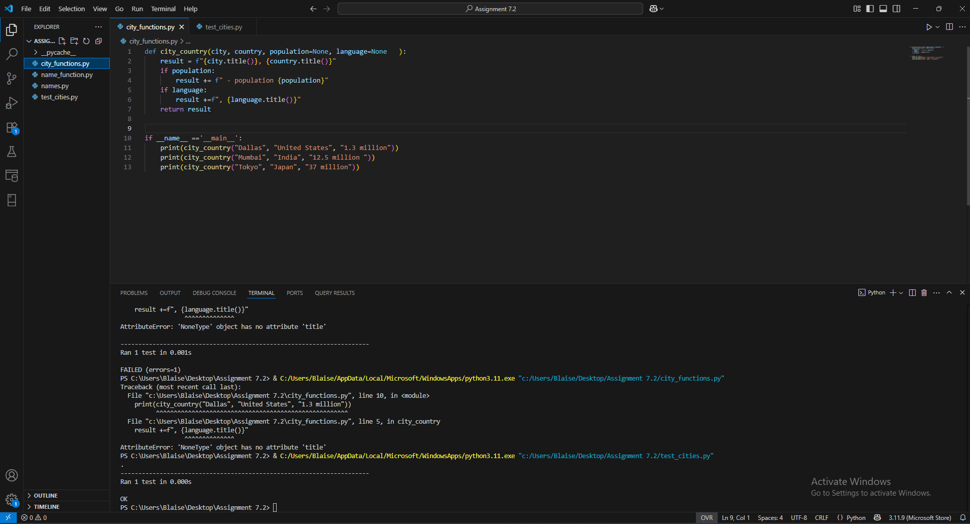

* Run city_functions.py. Call the function at least three times using a City, Country for one, City, Country, Population for the next and City, Country, Population, Language for the last. Excecute city_functions.py and take a screenshot of the result. Paste that screenshot into your Word document.

